Project: El Libro del Abecedario

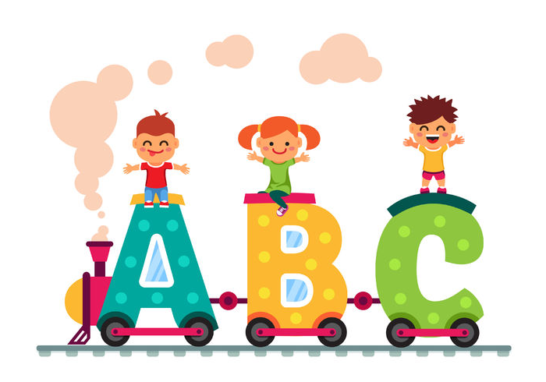

You are going to create your own amazing Spanish Alphabet EBook (a.k.a. Libro del Abecedario.) Señora Mariano made an example for your reference too.

-Use Google Slides to create your project and share it with [emariano@sageridge.org](mailto:emariano@sageridge.org)

-Include 2 letters in Spanish per slide and a word (NO ENGLISH please!)

-Include a Spanish word beginning with each letter of the alphabet on the same page as the letter

*Please choose simple and useful words, and *avoid slang or obscure words.* Imagine you are creating this for a kindergarten level.

-Find an appropriate picture/illustration online that represents the meaning of every word that you look up to include on each slide

­­­­-A cover page entitled "Mi Libro del Abecedario" and "por:_____________" with your Spanish nickname and last name

**The project will be due on: _____________. Please share your ebook with Sra. Mariano at** [**emariano@sageridge.org**](mailto:emariano@sageridge.org) **on or before that date.**

Project Guide:

Borrow a dictionary from the cubbies, to look up words in Spanish. Some students may need to share with a partner if there aren't enough. In the Spanish to English section, look up words and decide what you want to use in your project for the letters listed below, and write them in the space provided.

Letter Word in Spanish

Day 1 Homework:

Abuela - grandmother

Beisbol - baseball

Carreta - cart

Charca - pool or pond

Divan - couch

Evolucion - evolution

Frazada - blanket

Guacamol, guacamole - guacamole

Hermano/a - brother/sister/sibling

Inteligente - smart

jueves- Thursday

Kilogramo - kilogram

leche - milk

Ll llama - llama

Madre - mother

Letter Word in Spanish Meaning in English

Nabo - turnip

Ñ (for this letter, the word does NOT have to start with "ñ;" but has to have it somewhere in the word. Example "pi**ñ**ata" would be acceptable) Piñata - pinata

Day 2 in Class/Finish as homework if needed:

Ocho - the number 8

Pascua - easter

Queso - cheese

Robot - robot

RR (for this letter, the word does NOT have to start with rr;" but has to have it somewhere in the word. Example "pe**rr**o" would be acceptable) El perro - dog

Sabandija - worm

Tetera - teapot

Utillaje - tools

Vestimenta - clothes

W (this letter is a borrowed letter from English, so a lot of the options you'll see are English words with a similar spelling in Spanish.) Water closet - bathroom

Xilofon - xylophone

Yoyo - yoyo

Zoologico - zoo

Nombre: Lobo

Audience Participation Chart

When you classmates present their ABC book, please fill in the chart for what you see/hear.

| Name of classmate | 1 of the words from their presentation in Spanish | Meaning of that word in English |
| --- | --- | --- |
|  |  |  |
|  |  |  |
|  |  |  |
|  |  |  |
|  |  |  |
|  |  |  |
|  |  |  |
|  |  |  |
|  |  |  |
|  |  |  |
|  |  |  |
|  |  |  |
|  |  |  |
|  |  |  |
|  |  |  |
|  |  |  |
|  |  |  |